Rob Tribble

Currently –
Executive Director of Public Glass of San Francisco
Center for Glass Arts and Education - www.publicglass.org

Formerly --
Chief Evangelist / Domain Expert for commerce at Netscape Communications
30+ years in Software, 9 start-up companies, some success. http://www.robtribble.com/

Born 1947 - Lansing Michigan
Lived in Hawaii, Detroit, Chicago, Washington D.C. San Francisco
Travels to over 80+ countries, every continent except Antarctica

Education
BA-Economics – U. of Colorado
MBA – Finance & Quantitative Analysis

Artistic Education
My Mother, My Art Teachers in High School,
Public Glass – San Francisco,
San Jose State,
Pilchuck – School of Glass,
Corning Glass – School of Glass,
Murano, Italy – Private Instruction

Shows & Galleries
Keoki Gallery – Squaw Valley
Danville Fine Arts Gallery – Danville
Art Concepts – Walnut Creek
Susan Megson Gallery – NYC
Eclectic Image Gallery – Wailea, Maui
Sargents Fine Art – Lahina, Maui
OMNA – Santa Barbara
Open Studios - San Francisco
Phillips – Carmel

Artistic Influence
Father was an Engineer Teacher, Asst. Chief Engineer Ford Motor Company
Mother was an Artist, Painting, Mixed Media, Clay
Raised in Hawaii, the ocean, the sky, abundant life, color, and organic forms

I have always been an Artist, just spent most of my life being an engineer/businessman, Currently in between Movies, and looking for a new GIG. I love technology, I love logic, but, I also love glass. It is Addictive !!!

So How is it made ??

- Start with Hot Glass

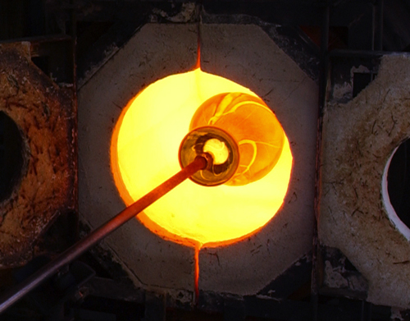
Hot Glass -- The process of blowing glass using a furnace that melts the glass at 2200 degrees Fahrenheit. Once the glass is gathered on the end of a pipe, the artist forms the hot glass using a "Glory Hole" (an oven that maintains a temperature of around 1200 degrees Fahrenheit). The resulting work is then slowly cooled in an annealing oven.
Glory Hole – The opening of the furnace used to keep the glass hot and workable. Several different sizes may be attached to a large furnace or you might have only one size on a small one that rotate open and closed depending on were the glass project is at. The cylinder is usually heated up to 2300 degrees.
2. Make Cane (Filigrana) using Color, and clear glass. Or Veiled Cane
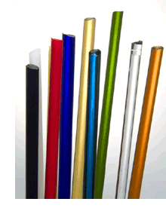
Cane – A cross section of glass made by pulling and stretching molten glass from both ends. Several color pattern and designs can be created. Whatever design is used along with the detail will continue to hold the precise shape, scale all the way down to an invisible dimension

Color - 99% of the color used comes from Germany or Bulgaria. The transparent colors are nearly all black until blown out in a piece and come shaped like a small rolling pin. The opaque colors are most often the same color as they started before melting

Filigrana, vetro a filigrana (Italian, "filigree glass") The generic name for blown glass made with colorless, white and sometimes colored canes. The filigrana style originated in Murano in the 16th century and spread rapidly to other parts of Europe, where façon de Venise glass was produced. Manufacture at Murano continued until the 18th century, and was revived in the 20th century.

Veiled Cane – Using a transparent color over an internal opaque color, and then covering all that with clear glass.

3. Make Cane from the Filigrana
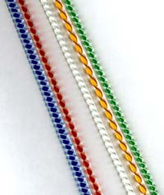

Zanfirico – cane with an external twisted / spiral pattern.

Ballentini – cane with an internal twisted / spiral pattern
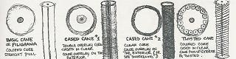

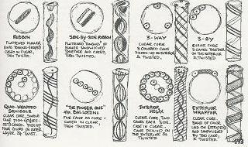

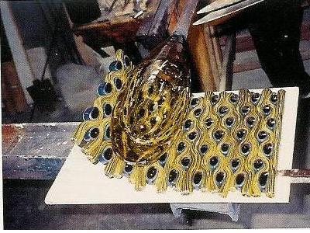
5. Make a roll-up using multiple types of cane onto a large molten glass bubble

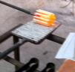

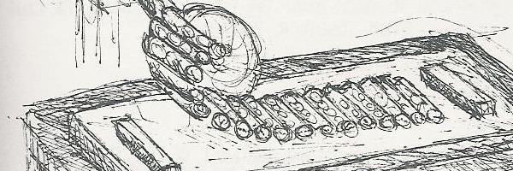

6. Make a rondelle for the wall
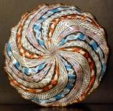
Rondelle – A flat blown glass that was spun hot.

7. Make a Gourd

with 3 sections using an Incalmo Technique, and a Reverse Axis switch to complete the Gourd. The sections may be a transparent color, opaque, with or without a spiral line, with or without some form of cane roll-up.

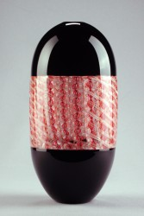
Incalmo - Joining two or more blown cups or sections while hot. This technique was not even taught in the US until the early 1980’s, It is very difficult, and requires a lot of time and practice to master.
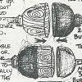

Reverse Axis – rotating the axis of the bubble by 90 degrees. This technique lets the piece have a completely different look, and is another example of the advanced Italian techniques used today.
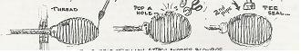
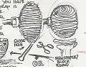

The results
